Steps involved for connecting MongoDB to PowerBI:

Prerequisites:

We need to make sure to download MongoDB, PowerBI and ProgressDataDirect.

After running IntelliJ commands, we need to continue the following steps:

We need to type ODBC Administrator In search box and select ODBC Administrator option(32 or 64 bit depending upon the system)

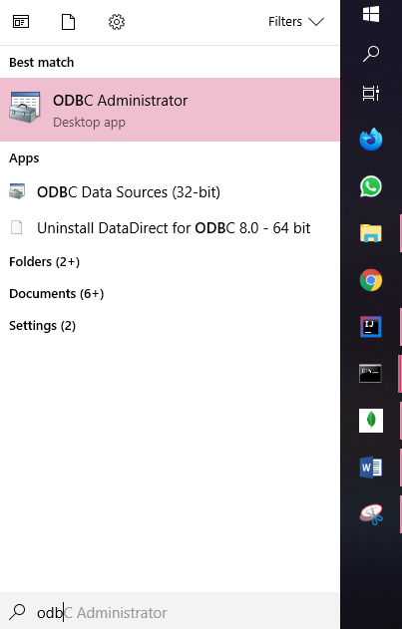

**Step2 :** After selecting ODBC data source administrator, a pop up will be opened where we need to select System DSN and choose the option called ADD

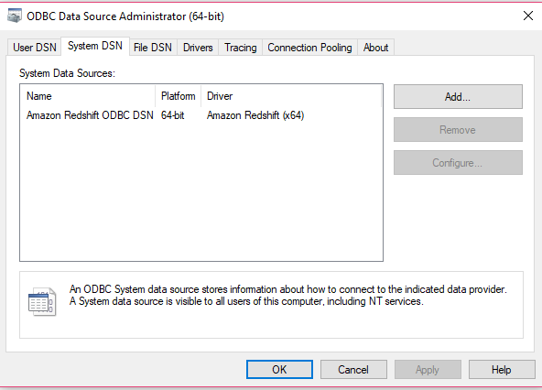

**Step 3:** When we click ADD button, a pop will be opened where we need to select the option called Data Direct 8.0 MongoDB and select the option called FINISH

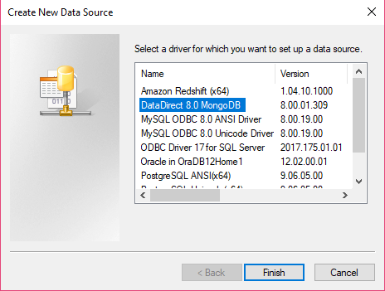

**Step 4:** Once you click finish, a pop will be opened with the following details

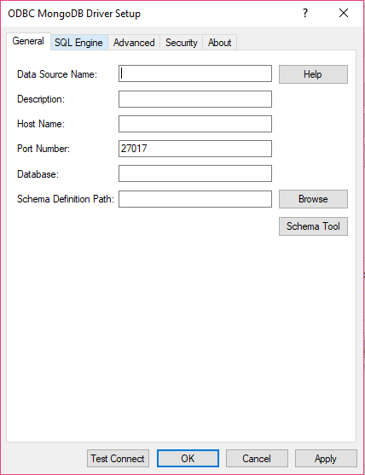

**Step 5:** We need to fill all the details depending upon your requirement and we need to choose the option called TEST CONNECT and a popup will be opened. In our case, I have used myDB because it is the data which we get when we run our Kafka Commands

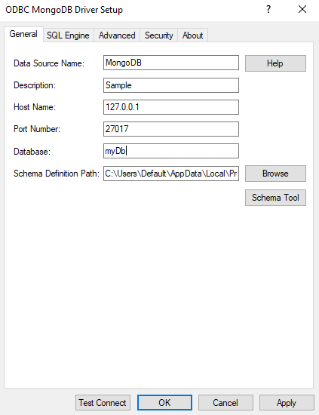

**Step 6:** Once the pop up is opened we need to enter the user name and password related to our MongoDB database

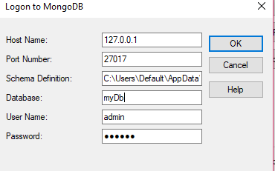

**Step 7:** Once we press the OK option, if the credentials and database details are correct, we will get an alert that a connection is established, we need to click OK button.

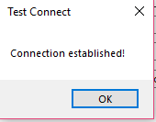

**Step 8:** Once the connection is established, we need to make sure to click on APPLY and OK buttons in order add the DSN to our System DSN



**Step 9:** Once everything is done, the DSN which we added is displayed in the System DSN of the ODBC Data Source Administrator.

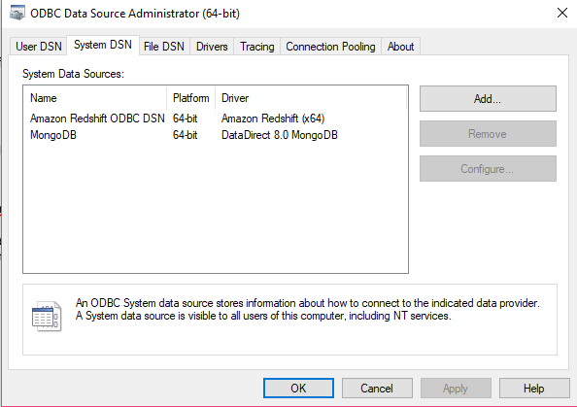

**Step 10:** Once we are done, we can now open PowerBI desktop and choose the option called GETDATA in order to get the data from MongoDb.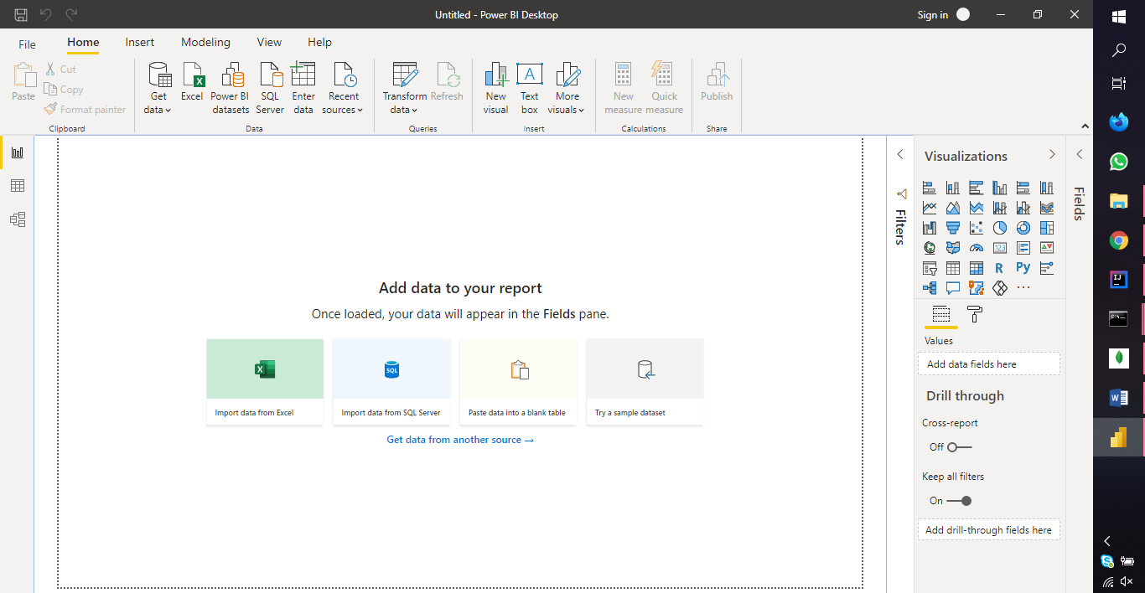

**Step 11:** When we choose the option GETDATA, the following options are displayed and we need to select the option OTHER and ODBC and we need to press CONNECT button

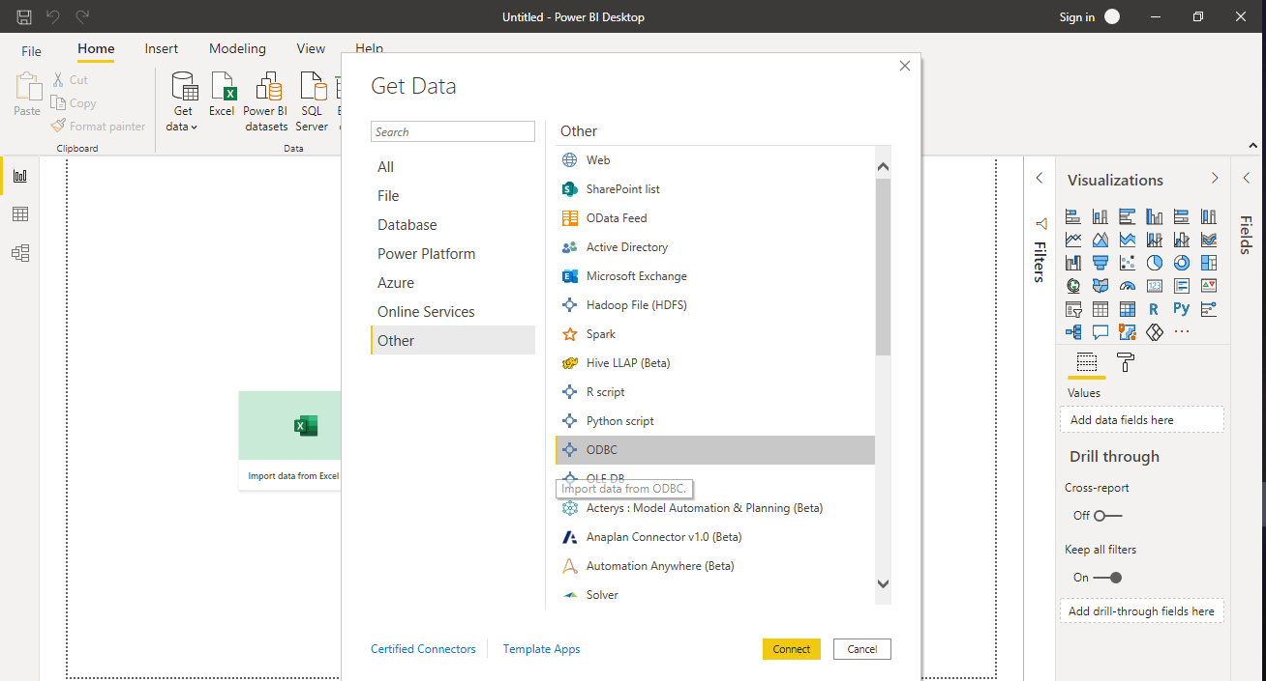

**Step 12:** Once we click on CONNECT button, an alert dialog is displayed where we need to enter our username and password of MongoDB and click on CONNECT option

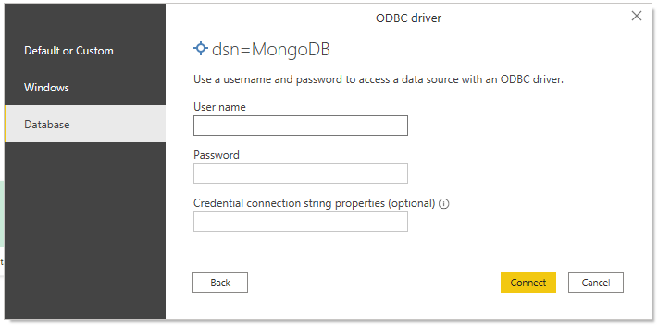

**Step 13:** Once we connect, another pop up will be displayed where we need to select the Data source name which we created in the early steps and we need to click OK

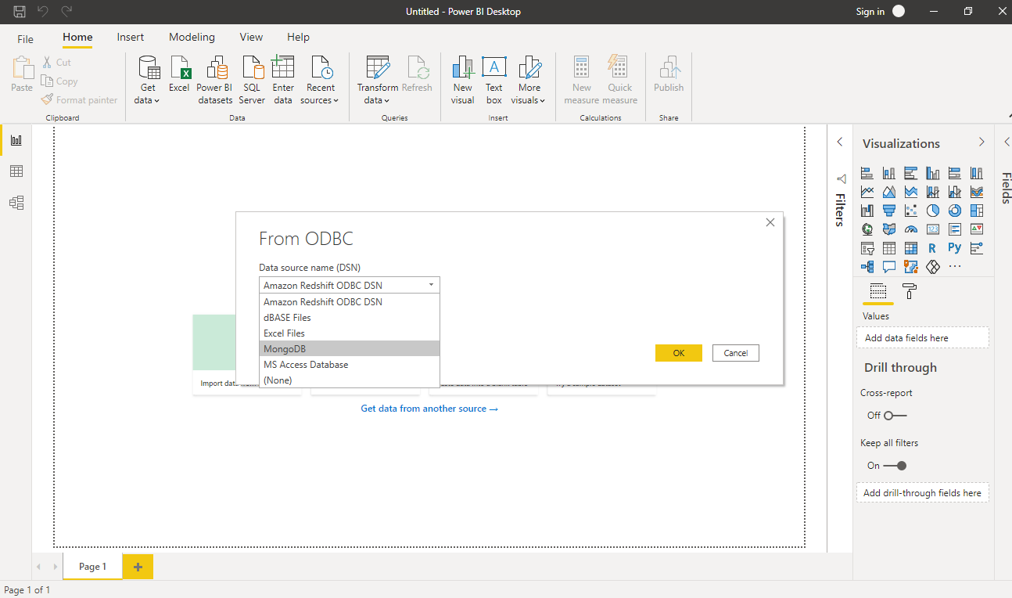

**Step 14:** Once we are connected, the tables present in the MongoDB are displayed as in the following Screenshot, later on we need to press the option called LOAD in order to LOAD the data.

